**Methodology**

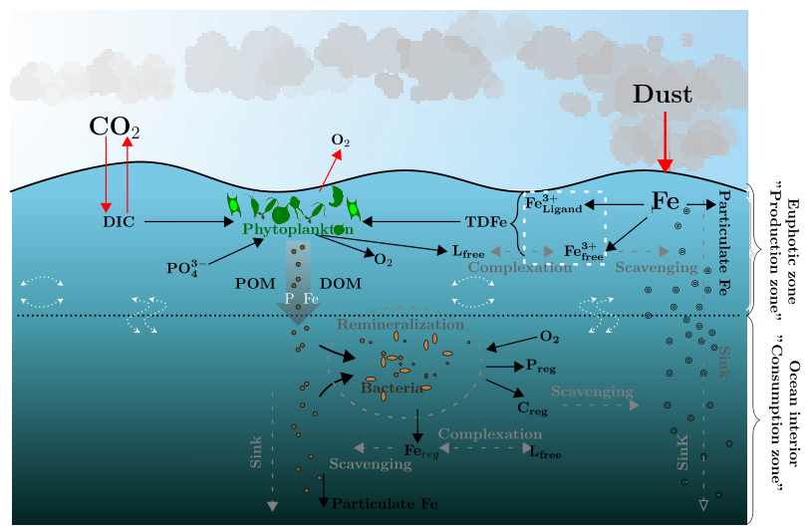

**Figure 2:** Graphic representation of the iron cycle in the cGENIE model. The ocean Iron source is the aeolian dust fluxes. A proportion of the Fe supplied will be available to 1) be complexed with ligand ($F{{e^{3+}}_{ligand}}_{}$), 2) keep in free state ($F{e^{ 3+}}_{free}$’) and 3) scavenging into POC (Particulate Fe) to sink through the water column. The Total Dissolved Iron pool (TDFe) will be used by the biological activity to generate POM and DOM. The remineralization process will regenerate nutrients and carbon.

**2.1 Model Description**

**Table 1. Model Parameters**

| **Symbol** | **Parameter** | **Value** |
| --- | --- | --- |
|  | Fe dust solubility | Variable |
| $R_{Fe}$ | Fe:P ratio | 0.47 nmol:1 mol |
|  | Fraction of DOM | 0.66 |
| ${ τ}_{bio}$ | Biological uptake time scale | 63.3827 yr |
| $λ$ | Remineralization rate | 0.5 yr-1 |
| $K_{Fe}$ | Iron half saturation constant | 0.1 nM kg-1 |
| $K_{PO4}$ | Phosphate half saturation constant | 0.1 uM kg-1 |
| $I_{0}$ | Light half saturation constant | 40 W m-2 |
| $k_{sv}$ | Scavenging rate | 1.44x10-6 Mol-1 m2 |
| $τ$ | Scavenging scaling rate | 0.1 |
| $K_{FeL}$ | Ligand stability constant | 1x10-11 M-1 |

In this work we use a version of GENIE focused on the carbon cycle, cGENIE muffin, free version v0.9.5 (it is hosted in the cGENIE Github repository). cGENIE is a type of Earth System Model of Intermediate Complexity (EMIC). This model implementation consists of the use of three modules, each one representing different components of the Earth system: In this work, we use the 3D frictional–geostrophic ocean module, with 16 depth levels, and 36 × 36 equal-area horizontal grid. In longitude, it has a compression of constant 10°, and is uniform in the sine of latitude, going from 3.2°, at the Equator, to 19.2°, at high latitudes (see (Edwards and Marsh, 2005), for full description). We also use the biogeochemistry module (Ridgwell et al., 2007), and an atmospheric component of the 2D energy–moisture balance model (EMBM) with prescribed climatological wind fields (Cao et al., 2009). The continental distribution and bathymetry are published in Ridgwell et al. (2007).

For this study, we focused on the biological pump of soft tissues. For this purpose, a co-limitation scheme of iron and phosphorus to the carbon cycle (Fe/C and P/C) was implemented following Tagliabue et al. (2016). Additionally, a simplified scheme of organic complexing, nutrient removal, and Particulate Organic Carbon (POC) sink was implemented following the methodology proposed by Parekh et al. (2004, 2006). **Table 1** summarizes the data sets and values used. The circulation model uses both Temperature (properly parameterized (van de Velde et al., 2021)), salinity and 33 biogeochemical tracers, to describe the interactions between nutrients. In order to make a correct carbon inventory, tracers and preformed nutrients were used following the base configuration of Cao et al. (2009).

The marine biogeochemical cycling module of cGENIE, called BIOGEM (Ridgwell et al.,2007), carbon sequestration is controlled by biological export. For a complete description see Ridgwell et al. (2007a). In general terms, the biogenic uptake of dissolved nutrients (P and Fe), dissolved tracers and DIC occurs in the ocean euphotic zone (first 80.8 m according to the model configuration) and is of vital importance to determine the export flux of particulate matter. Then the remineralization by ocean bacteria (at a depth of 589.9451 m in cGENIE) will result in inorganic nutrients (P and Fe among others) and carbon regenerated. This last contain POC, whose concentration will be decisive to know the efficiency of the biological pump (define as $P^{*}= P_{reg}/P_{total}$).

**2.2 Experiment design**

Most models usually reproduce the ocean nutrient consumption and release using the stoichiometric ratio of Redfield (1963). Even though this method works as a global average between basins, there is variability. Both P and Fe have low ocean concentration in many ocean basin, in order to reproduce its limiting effects on primary productivity we use a colimitation scheme (see **Figure 2**).

The original (Ridgwell et al. (2007a)) and the current version of the cGENIE model include a co-dependency between the concentration of dissolved phosphate [P] and the biological uptake of C at the surface ocean:

$P:C=1:{\left(\frac{[PO_{4}]}{144.9 μmol L^{-1} } + 0.0060\right)}^{-1}$ Eq. 1

However, Fe was previously parameterized on cGENIE model by the stoichiometric ratio of Redfield (1963), from Tagliabue et al. (2016), a new simplified representation of the iron cycle is introduced.

The surface ocean of cGENIE is highly oxygenated water, hence, of the total Fe input, most of it is rapidly oxidized to its Fe3+ form (less bioavailable). Therefore, Fe dissolution is a determining factor in photosynthesis and it will depend on the temperature, salinity, and PH of the water. The total dissolved Fe scheme will be composed of 1) Fe free ($F{e^{ 3+}}_{free}$) and 2) a Fe bond to ligand ($F{{e^{3+}}_{ligand}}_{}$). The $F{{e^{3+}}_{ligand}}_{}$ have the greatest proportion in the real ocean (~99%), while the Fe' component is the only one that is susceptible to be scavenging by POC towards abyssal depths (at a fixed rate $k_{sv}$), being eliminated from the system (non-reversible scavenging). The $F{e^{ 3+}}_{free}$ scavenging will occur when TDFe > $L_{T}$.

The concentration of total ligands in cGENIE ($L_{T}$ = $L_{free}$ + $F{{e^{3+}}_{ligand}}_{}$), is invariant and uniform in the water column (0.1 nM) following what was proposed by Parekh et al. [2005] and Doney et al. [2006]. This equilibrium relationship allows us to calculate the concentration of $F{e^{ 3+}}_{free}$ at each time step through:

$K_{L}$ = $\frac{F{{e^{3+}}_{ligand}}_{}}{F{e^{ 3+}}_{free} x { L}_{free}}$ Eq. 2

Where $K_{L}$ is the strength of the binding.

Regarding the potential capture of TDFe during biological uptake ($τ_{bio}$), the variable C/Fe ratio allows reflection of the various scenarios of Fe availability, therefore, of Fe requirements at the cellular level. Thus, under higher limitation, less Fe concentration will be required and vice versa (a minimum radius of 250,000 is imposed during maximum Fe limitation).

$Fe:C = \frac{1}{min(250000,103700xFe_{T^{-0.4225}})}$ Eq. 3

**2.2.1 Forcing**

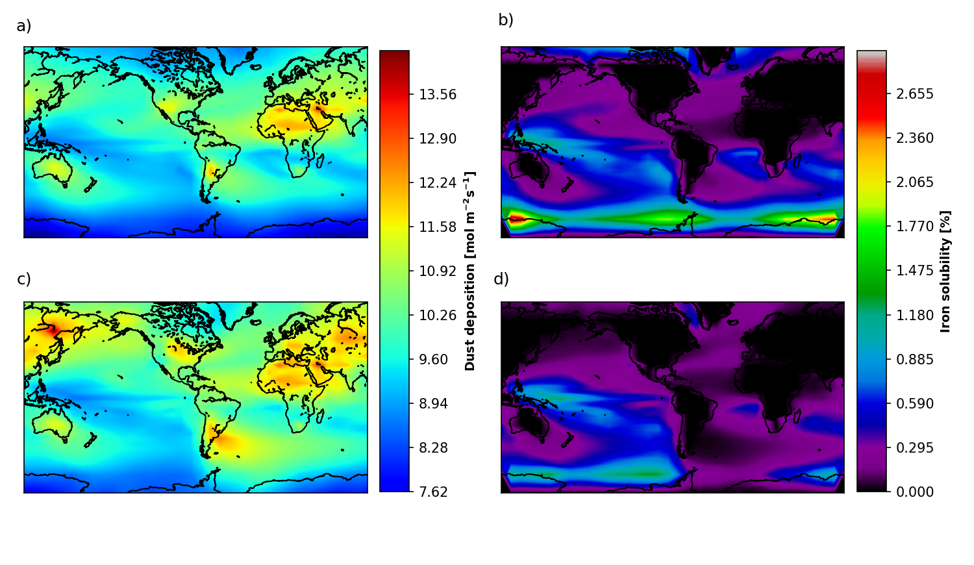

**Figure 3:** Dust deposition fluxes from Mahowald et al. (2006) (left panels) and calculated total iron fluxes (right panels), for the Holocene (top panels) and Last Glacial Maximum (bottom panels).

Regarding the forcing of the system, we worked with: 1) 6 pairs of dust fluxes fields from the LGM and Holocene period. One of them is empirical data called “Lambert” (Lambert et al., 2015), the rest are CMIP5 model simulations surface dust flux reconstructions called “Albani”, “Takemura”, “Ohgaito”,“MIROC-ESM” and “MRI-CGCM3” (Albani et al., 2014; Takemura et al., 2009; Ohgaito et al., 2018; Sueyoshi et al., 2013; Yukimoto et al., 2012) for more detail see Lambert et al. (2021); and since the solubility of iron is not well known, both today and during the past, and is decisive in the total concentration of dissolved Fe, 2) different iron solubility fields were created for each of these six initial flux field pairs. In replacement of the fixed Fe solubility used in previous experiments (). These latest results from the application of a linear regression model, estimated from the relationship between the Holocene dust flux field of Mahowald et al. (2006) and the calibrated iron solubility field, developed by the marine biogeochemical cycling module of cGENIE, called BIOGEM (Ridgwell et al.,2007).

The calibrated Fe solubility field was estimated using the equation *, which shows the inverse relationship, at the ocean surface, between the Fe solubility and the concentration of suspended particles from aeolian deposition:

$Υ_{Fesol}$ = $γ_{Fesol} x {\left(C_{dust}\right)}^{-0.5}$

where $Υ_{Fesol}$ is the fractional solubility of Fe in dust, $γFeso$ is a scaling factor, and $C_{dust}$

is the concentration of dust in the surface ocean layer (mol kg -1 ). Normally, the value of $γ_{Fesol}$ is applied spatially, and continuously re-calculated in the model in order to achieve a specific mean flux-weighted average solubility – ${\underline{Υ}}_{Fesol}$. However, in this study, we introduce the $γ_{Fesol}$ of each grid cell and with the square root of the Holocene dust field from Mahowald et al. (2006) we obtained the first Fe solubility field (see **Figure 3**).

Additionally, for each iron solubility reconstruction, we varied its values in only one of the 5 HNLC regions and globally. This alteration is the product of the application of 4 factors that multiply the original values of the iron solubility fields. These factors are 1/2, 2/3, 2, and 3. Thus, for each of the 6 pairs of iron solubility reconstructions, 5 modified iron solubility reconstructions were produced (one for each of the 5 HNLC zones) plus 4 fields at a global scale, by 4 scalar factors. Consequently, the model was forced with 240 different regionally modified patterns, plus 48 global modified control states, plus 12 simple (unmodified) controls, representing standard LGM and Holocene conditions in terms of iron solubility and six dust flux fields to estimate CO2 uptake.

**2.2.2 BIOGEM Dissolved Iron**

Dissolved Fe input to the system, consumed during biological uptake, will be driven by various dust flux fields deposited in the surface ocean. Additional supplies of iron associated with sedimentary processes in the ocean, or any other type of source other than aeolian deposition, will not be considered.

In **Figure 1** we see the total dissolved Fe concentration at the ocean surface estimated by BIOGEM from a given Holocene dust field developed by Lambert…. This field is the result of the sum of the inorganic solubilization due to chemical effect ($F{e^{3+}}_{free}$) plus the organic complexation with ligands ($F{e^{3+}}_{ligand}$).

Regarding the distribution of dissolved Fe, we see that the concentrations of dissolved Fe are higher in the southern oceans (a region highly limited by Fe) compared to the tropical and subtropical zones. This is because at high latitudes both the temperature and the pH of the water are lower, in contrast, the saturation point of Fe (II) is higher. Therefore, it will be a higher concentration of solubilized Fe, generating a better Fe Biological utilization in the surface layers as a result of high organic complexation that protects dissolved Fe from scavenging. In the tropical zones, mainly towards the western side of the basins, we have an intermediate concentration level. Although these regions are abundantly deposited with dust, the depth of remineralization is very shallow, which means that the Fe is quickly eliminated by scavenging. In the subtropical zones, we have the minimum concentration of dissolved Fe. Here the lack of Fe source, the high depletion, due to nitrogen fixation, and the shallow remineralization depth converge.

**2.3 Simulation**

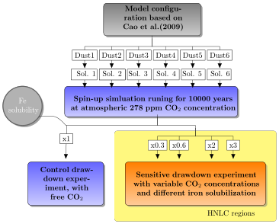

**Figure 4.** Flow chart of the experiments' implementation. The gray box shows the general configuration used for spin-up and sensitivity experiment simulations. White boxes labeled *Dust 1-6* represent the six Last Glacial Maximum (LGM) and six Holocene dust deposition flux fields used as input to the simulations, while the associated input fields of fractional iron (Fe) solubility are represented by white boxes labeled *Sol. 1-6*. The top blue box represents the spin-up simulations run for each input field of dust flux, using a fixed value for atmospheric carbon dioxide (CO2) concentration. The bottom blue box represents the control simulations run with unprescribed CO2 for each input dust field (six for LGM and six for the Holocene). The bottom yellow box represents the main set of sensitivity experiment simulations, in which for all 12 input fields of fractional iron solubility, all grids of a given high-nutrient, low-chlorophyll (HNLC) ocean basin are multiplied by the same scalar factor (0.3, 0.6, 2.0 and 3.0). The experiments were run for 10,000 years.

We initialized by performing 6 different pre-industrial equilibrium experiments (spin-up), in which the atmospheric CO2 concentration have been settled at 278 ppmv compared to the control (free CO2), using the cGENIE Earth System model, and running for 10000 years. . (to reach the equilibrium state). We forcing the experiments using Holocene dust and iron solubility fields from different authors, with the goal of compared the ocean carbon uptake potential, even so, they have the same pCO2 in their spin-up have variable oceanic nutrients inventory and carbon distribution, which will affect the behavior of the biological pump. Starting from the end of each spin-up, we run global and regional sensitivity experiments (see **Figure 4**) for the Holocene and LGM data, and again we allow the model to run 10000 years. Finally, we took the mean of the last 500 years of pCO2 estimates from each simulation (240 regional, 48 modified controls, and 6 standard controls, hence, 294 in total).